## BULAN WEB-BASED INCIDENT, ACTIVITY REPORT AND

**MONITORING INFORMATION SYSTEM FOR MUNICIPAL**

**DISASTER RISK REDUCTION AND MANAGEMENT (MRRMO)**

A Capstone Project

Presented to the Faculty of

Sorsogon State University

Bulan Campus

Bulan, Sorsogon

In Partial Fulfillment of the

Requirements for the Degree

Bachelor of Science in Information Technology

BY:

RICHARD GEOCA

NELSON AMOR

PHILIP HACHERO

JOHN RENZ GUARDA

MART JOSAM GUBAN

2022

CHAPTER

I Introduction . . . . . . . . . . . . . . . . . . . . . . . . . . . . . . . . . . . . . . . . 1 1.1 Project Context . . . . . . . . . . . . . . . . . . . . . . . . . . . . . . . . . . . 2 1.2 Purpose and Descriptions . . . . . . . . . . . . . . . . . . . . . . . . . . . 3 1.3 Objectives of the Study . . . . . . . . . . . . . . . . . . . . . . . . . . . . 4 1.4 Scope and Limitations . . . . . . . . . . . . . . . . . . . . . . . . . . . . . 5

II Review of Related Systems . . . . . . . . . . . . . . . . . . . . . . . . . . . . . 7

III Technical Background . . . . . . . . . . . . . . . . . . . . . . . . . . . . . . . . . . . . . . 19 3.1 System’s Development Specification . . . . . . . . . . . . . . . . . . . . . 19 3.1.1 Hardware Specification . . . . . . . . . . . . . . . . . . . . . . . . . . . 19 3.1.2 Software Specification . . . . . . . . . . . . . . . . . . . . . . . . . . . . 20 3.2 User’s System Specification Requirements . . . . . . . . . . . . . . . . 20 3.2.1 Hardware and Software Specification Requirements . . . . 20 3.3 Technical Terms . . . . . . . . . . . . . . . . . . . . . . . . . . . . . . . . . . . . . . . 21

IV Design and Methodology . . . . . . . . . . . . . . . . . . . . . . . . . . . . . . . . . . . 24 4.1 Concept . . . . . . . . . . . . . . . . . . . . . . . . . . . . . . . . . . . . . . . . . . . . . . 25 4.1.1 System Architecture Diagram . . . . . . . . . . . . . . . . . . . . . . 29 4.1.2 Data Flow Diagram . . . . . . . . . . . . . . . . . . . . . . . . . . . . . . 32 4.1.3 Use-Case Diagram . . . . . . . . . . . . . . . . . . . . . . . . . . . . . . 35 4.1.4 Activity Diagram . . . . . . . . . . . . . . . . . . . . . . . . . . . . . . . . 38

**CHAPTER I**

**Introduction**

Republic Act 10121 of 2010, also known as the Philippine Disaster Risk Reduce and Management Act, the Department of Social Welfare and Development (DSWD) shall act as the vice chair for disaster response of the national disaster risk reduction management council (NDRRMC). The department as the vice-chair, shall lead the response cluster through the cluster approach, which was institutionalized to effectively lead the Philippine government’s disaster response operations.

Thus, the need to establish clear disaster data as basis for delivering psychosocial and protective services to disaster-affected and internally displaced persons & families especially the dis advantaged poor, women, children, elderly, and persons with disability. It is in this light that the department, through the disaster response operations monitoring and information center (DROMIC), aims to enhance and systematize its disaster monitoring and reporting system through this guideline.

Study variables included system user satisfaction, willingness to report, number of reports, severity of the events, and efficiency of the reporting process. In addition, the Web-based reporting system was used more often than the paper system. The percentages of events reported were significantly higher in the Web-based system in laboratory, environment/device, and incidents occurring in other units, whereas the proportions of reports involving bedsores and dislocation of endotracheal tubes were decreased.

This study is also focusing about the disaster risk reduce and management, the department was including good governance, risk assessment and early warning, knowledge building and awareness raising, reducing underlying risk factors and preparedness for effective response. The purpose of this study is to identify and implement cost-effective risk reduce measures and or the strategies. Disseminate of the information and raise public awareness about those hazards, vulnerabilities and risk.Bulan Web-Based Incidents in Activity Monitoring Reporting System in Municipal Disaster Risk Reduce and Management Office (MDRRMO), the department throughout the disaster response operations monitoring and reporting system through this recommendation.

**Project Context**

This proposed project entitled “Bulan Web-Based Incident, Activity Report and Monitoring Information System for Municipal Disaster Risk Reduction and Management Office (MDRRMO**)**” has been monitoring and producing report on disaster events in MDRRRMO. Be it hydro meteorological, geological or human – induced such as armed conflicts and social disorganization. The information gathered throughout those years provided a wealth of information as to disaster response trends, community vulnerabilities, and local capabilities.

Bulan Web-Based Incident, Activity Report and Monitoring Information System, integrated process of planning, organizing, coordinating, and implementing measures which are necessary for prevention of threat of any disaster. Reduction of risk of any disaster or its consequences. Readliness to deal with any disaster.

The result of the study will benefit of the following: Municipal Disaster Risk Reduction and Management Office. This project will help MDRRM office for viewing personal records.

**Patient:** the study would requesting issued a certification of complaints to MDRRM Office.

**MDRRMO Responder:** the study would enhance or collecting all documents or file.

**MDRRMO Head:** the study will take monthly transaction report or data information to implement environmental and natural resources management in the municipality that conform to accepted standards.

**Purpose and Description**

Web-based reporting system was used more often than the paper system. The percentages of events reported were significantly higher in the Web-based system in laboratory, environment/device, and incidents occurring in other units, whereas the proportions of reports involving bedsores and dislocation of endotracheal tubes were decreased. The study recommends that the data entry process be simplified and the network system be improved to increase user satisfaction and reporting rates.

In this study the information acquired is further processed to detect road incidents. Furthermore, a navigation system is also developed to report the incident to the nearest hospital. Preliminary data include system factors reported, degree of patient harm, reporting times, and evaluations of the system. Qualitative and quantitative data are reported back to the ICU site study teams and frontline staff through monthly reports, case discussions, a quarterly newsletter, calamity, human-induced disaster, disaster preparedness, disaster response, early recovery.

The web-based reporting system was preferred over the paper-based system. To boost user satisfaction and reporting rates, the study proposes that the data entry procedure be streamlined and the network system be upgraded. The proposed approach is validated through simulations and comparison with a real data set of road accidents acquired from Road Safety Open Repository, and shows promising results in terms of accuracy.

**Objective of the Study**

The overall objective of this guideline is to provide standard procedures in gathering data, submission and dissemination of disaster response operations monitoring reports, standardization of DROMIC reporting guidelines and harmonization of reporting protocols at the field and central office.

Specifically, it aimed to:

1. To design and develop that technical assistance and capabilities on disaster reporting are effectively cascaded from central office and field office.
   1. Patient
   2. Mdrrmo Responder
   3. Mdrrmo Head
2. To provide a module for:
   1. Data Generation
   2. Validated Form
   3. Information Dissemination
   4. Submission
3. Test and evaluate the proposed system for Bulan Web-Based Incidents in Activity Monitoring Reporting System in Municipal Disaster Risk Reduce and Management Office.
   1. Functionality Suitability
   2. Performance Efficiency
   3. Compatibility
   4. Usability
   5. Reliability
   6. Security
   7. Maintainability
   8. Portability

**Scope and Delimitations**

The main focus of this project is to develop a Bulan Web-Based Incident, Activity Report and Monitoring Information System for Municipal Disaster Risk Reduction and Management Office (MDRRMO**).** The system has a voluntary and anonymous web – based incidents reporting system was introduced. For the new organizational structure a clinical risk management committee, a department of clinical quality management, and area clinical risk managers were established with their respective roles clearly defined to advance the plan do study act cycle and to integrate efforts.

The purpose of the study have been improving the reporting system, responsible persons, staff education, and a variety of feedback procedures can help promote a safety culture, multidisciplinary collaboration, and strong managerial leadership resulting in system oriented improvement.

All cost of incidents Climate or Emergency are covered of MDRRMO. Only employees need to access the data, which is the responder must be guided to record the data, and they will share the official link. The client can only access the system. Modules and validated forms were can print or not, because all of documentation forms are served in website for more information record.

The process of the system is to arrange the category of incident report for example road incident, flood incident, landslide, and typhoon. after that the responder will fill out the data based form, which are the date, coved related, type of incident, information contact details , incident location, time incident, occurred, time incident reported, time incident response, initiated, time incident terminated, incident description/ action take, number of person involved, name of victim’s person’s involved, age, sex, address, vehicle used, name of driver, responder team, name of responder, devices used, photos taken by, report prepared by, date recorded, and after that will submitted to mdrrmo head.

This Memorandum Circular shall apply to all DSWD central and disaster risk reduction and management (DRRM) data and information. These reporting guidelines shall be observed by all agencies engaged in data generation, preparation, validation and dissemination from the national, regional, provincial, city/municipal levels and other stakeholders on the DSWD – DRRM data and information management.

A DROMIC report is prepared for every natural or human-induced disaster incident affecting at least thirty (30) families and/or causing damages to more than ten (10) houses. A report will also have to be submitted for incidents that required the Field Office to provide disaster relief assistance to affected families even if family beneficiaries are less than thirty (30).

**CHAPTER II**

**Review of Related Literature**

**Foreign**

According to Gong, Hong Kang, Xinshuo Wu, Lei Hua Applied clinical informatics 8 (03), 893-909, 2017 Electronic patient safety event reporting (e-reporting) is an effective mechanism to learn from errors and enhance patient safety. Unfortunately, the value of e-reporting system (a software or web server based platform) in patient safety research is greatly overshadowed by low quality reporting. This paper aims at revealing the current status of system features, detecting potential gaps in system design, and accordingly proposing suggestions for future design and implementation of the system.

This articles was discussing about the quality of reporting and monitoring for enhancing the patient safety. This paper aims at revealing the current status of system features, detecting potential gaps in system design, and accordingly proposing suggestions for future design and implementation of the system.

According to Peter E Rivard, Amy K Rosen, John S Carroll Health services research 41 (4p2), 1633-1653, 2006 To assess the potential contribution of the Agency for Healthcare Research and Quality Patient Safety Indicators (PSIs) to organizational learning for patient safety improvement.

According to John M Gallagher et al. Prehosp Emerg Care. Jan-Mar 2012. Experience with an anonymous web-based state EMS safety incident reporting system John M Gallagher et al. Prehosp Emerg Care. Jan-Mar 2012. Patient and provider safety is paramount in all aspects of emergency medical services (EMS) systems. The leaders, administrators, and policymakers of these systems must have an understanding of situations that present potential for harm to patients or providers.

According to Albarrak, A.I., Almansour, A.S., Alzahrani, A.A. et al. The purpose of patient safety is to prevent harm occurring in the healthcare system. Patient safety is improved by the use of a reporting system in which healthcare workers can document and learn from incidents, and thus prevent potential medical errors. The present study aimed to determine patient safety challenges facing clinicians (physicians and nurses) in emergency medicine and to assess barriers to using e-OVR (electronic occurrence variance reporting).

According to B Hoffmann, M Beyer, J Rohe, J Gensichen, FM Gerlach BMJ Quality & Safety 17 (4), 307-312, 2008 Incident reporting systems have been established primarily in the inpatient setting. Their goal is the identification of safety risks in healthcare as a precondition for improvements in the overall quality of care. Knowledge about medical errors in general practice is sparse, as are reporting systems for patient safety in this setting. This article describes the development, structure and initial results of an incident reporting system for general practices in German-speaking countries.

According to K Nakajima, Y Kurata, H Takeda BMJ Quality & Safety 14 (2), 123-129, 2005 when patient safety programs were mandated for Japanese health care institutions, a safety culture, a tool for collecting incident reports, an organizational arrangement for multidisciplinary collaboration, and interventional methods for improvement had to be established.

According to Jag Ahluwalia Critical incident reporting (CIR) systems refer to the structured reporting, collation and analysis of such incidents. This article describes the attributes required for an effective CIR system. Example neonatal trigger events and a management pathway for handling a critical incident report are described. The benefits and limitations of CIR systems, reactive and prospective approaches to the analysis of actual or potential critical incidents and the assessment of risk are also reviewed. Individual human error is but one contributor in the majority of critical incidents. Recognition of this and the fostering of an organizational culture that views critical incident reports as an opportunity to learn and to improve future patient care is vital if CIR systems are to be effective.

According to John R Clarke the American Surgeon 72 (11), 1088-1091, 2006 The Institute of Medicine has recommended systems for reporting medical errors. This article discusses the necessary components of patient safety databases, steps for implementing patient safety reporting systems, what systems can do, what they cannot do, and motivations for physician participation. An ideal system captures adverse events, when care harms patients, and near misses, when errors occur without any harm. Near misses signal system weaknesses and, because harm did not occur, may provide insight into solutions. With an integrated system, medical errors can be linked to patient and team characteristics. Confidentiality and ease of use are important incentives in reporting. Confidentiality is preferred to anonymity to allow follow-up. Analysis and feedback are critical. Reporting systems need to be linked to organizational leaders who can act on the conclusions of reports. The use of statistics is limited by the absence of reliable numerators and denominators. Solutions should focus on changing the cultural environment. Patient safety reporting systems can help bring to light, monitor, and correct systems of care that produces medical errors. They are useful components of the patient safety and quality improvement initiatives of healthcare systems and they warrant involvement by physicians.

According to Choy Yin Choy Current Opinion in Anesthesiology 21 (2), 183-186, 2008 Critical incident monitoring is a valuable tool in ensuring patient safety due to its low cost and the ability to provide a comprehensive body of detailed qualitative information. The qualitative information gathered can be used to develop strategies to prevent and manage existing problems, as well as to plan further initiatives for patient safety. Novel approaches should complement existing methods to achieve better results. The development of a culture which emphasizes safety should go hand in hand with current audit activities.

According to RP Mahajan British journal of anaesthesia 105 (1), 69-75, 2010 The success of incident reporting in improving safety, although obvious in aviation and other high-risk industries, is yet to be seen in health-care systems. An incident reporting system which would improve patient safety would allow front-end clinicians to have easy access for reporting an incident with an understanding that their report will be handled in a non-punitive manner, and that it will lead to enhanced learning regarding the causation of the incident and systemic changes which will prevent it from recurring. At present, significant problems remain with local and national incident reporting systems. These include fear of punitive action, poor safety culture in an organization, lack of understanding among clinicians about what should be reported, lack of awareness of how the reported incidents will be analyzed, and how will the reports ultimately lead to changes which will improve patient safety.

**Local**

According to Charles Vincent BSc, M.Phil, PhD View in Scopus (Professor of Clinical Safety Research)

Great er focus is needed on improving patient safety in modern healthcare systems and the first step to achieving this is to reliably identify the safety issues arising in healthcare. Research has shown the accident and emergency (A&E) department to be a particularly problematic environment where safety is a concern due to various factors, such as the range, nature and urgency of presenting conditions and the high turnover of patients. As in all healthcare environments clinical incident reporting in A&E is an important tool for detecting safety issues which can result in identifying solutions, learning from error and enhancing patient safety.

This study must be responsive and flexible to the local circumstances and work for the department to support the clinical governance agenda. They can also arising the issues by identifying the reliability of the safety.

According to Mary Ann E Ignaco Proceedings of the 20th Annual SIG Conference on Information Technology Education, 162-162, 2019 Development of Mobile Application for Incident Reporting" is an application that aimed to report and respond to crime incidents that may occur in the Philippines community. It includes two main applications such as Crime Reporting, Crime Responder and the website. The Crime Reporting application used by the victim or witness, to submit an incident report with photos that are then coordinated to either the nearest barangay or police station. The Crime Responder application used by the barangay or police officials for notification and immediate response on the given report. The website for incident demographics. The application runs in Android phones with a 4.4 to 6.0 version and has an internet connection. The 30 participants, including 10 end-users, 5 police officers, 5 barangay officers, 7 IT teachers, and 3 Android programmers using the ISO 25010 Model as an assessment tool, assessed it.

This study is to design and develop an application that can be utilized to transmit and documents incidents type, location and images, among that aimed to report and respond to crime incidents that may occur in the MDRRMO community.

According to Jan Peter Bulusan, Bradd Melton Cabaluna, Daniel John Macaraig, Abner Cruz Abstract Proceedings International Scholars Conference 7 (1), 1751-1762, 2019 reporting actual incidents through short messaging systems and telephone calls are tedious, prone to errors and misinterpretations. Developing a mobile application that can be utilized to transmit incident type, location, and images among other details can provide assistance in emergency situations. The software development method followed in this study was the prototyping model, where initial versions of the software were shown to the end users for it to be refined to their needs. The target users of the mobile application are a group of 38 Adventist motorcycle riders from Silang, Cavite, Philippines who are trained to be first responders. Interviews with end users and benchmarking on related systems were conducted to meet results. The end users’ feedback on the developed application can be summarized as having high accuracy, less prone to errors, and ease-of-use. Through Global Positioning Systems available on modern smart phones, reporting a specific incident location can be as accurate as within five meters. The report receiver can view the location in a map. Minimizing text entry and utilizing control elements not only improve reporting time but also reduce chances of committing errors. Further, the application can provide map location and contact information of the emergency facilities near the incident site. Reported information is also centrally stored for references to improve response processes. Once substantial data is gathered from this system, it can be data-mined to predict possible hotspots, peak times and other information on the occurrences of incidents. To implement the system to a larger geographical territory, the proponents suggest employing artificial intelligence which can automatically identify and request help from the nearest possible medical facilities.

This article was focusing about the preceding international. The report receiver can view the location in a map. Minimizing text entry and utilizing control elements not only improve reporting time but also reduce chances of committing errors. Further, the application can provide map location and contact information of the emergency facilities near the incident site. Reported information is also centrally stored for references to improve response processes. Once substantial data is gathered from this system, it can be data-mined to predict possible hotspots, peak times and other information on the occurrences of incidents. To implement the system to a larger geographical territory, the proponents suggest employing artificial intelligence which can automatically identify and request help from the nearest possible medical facilities.

According to Ramon L Rodriguez, Elcid A Serrano, Ariel Kelly D Balan 2017 IEEE Region 10 Symposium (TENSYMP), 1-5, 2017 In the past years, the Philippines recorded different disasters in diverse parts of the archipelago. The most frequent natural disasters were floods and storms that bring hazards to the people. The country has high level of exposure to hydro-meteorological hazards due to its geography. Because of the frequency, intensity, and variability of the hazards the government is compelled to adopt disaster risk reduction and management and climate change adaptation.

In this study, we developed a web-based application for Relief and Casualty Monitoring and Early Warning System for Local Government Units in the Philippines tested in two case sites in the Philippines. Results show that the requirements set by the user were met. The overall evaluation shows that the system is useful in addressing some of the findings of the commission on audit assessment report in helping the local government unit in the Philippines in early warning for its constituents.

Carlo Andolfo Graduate Studies, 2016 Construction has one of the highest rates of accidents among all industries worldwide. In Canada, 22% of workplace fatalities are recorded in the construction industry. An analysis conducted in this study showed that one of the main causes of accidents on construction sites is workers’ lack of awareness of proximity of danger. The objective of

This study is to develop a Site Safety Monitoring System that helps improve safety on construction sites by providing safety status of workers in real-time. The system is composed of an available UWB Real-Time Locating System that estimates workers’ location on the site, and a Detection Model that detects when workers are in the proximity of danger using the provided location estimations.

According to GAM Narciso, DC Fargas Jr, CG Candido, JM Medina, MLP Tinio, AC Blanco Development of the Masdan Mobile Application and Web-Based GIS Interface for the Monitoring and Management of the Manila Bay Environment The International Archives of Photogrammetry, Remote Sensing and Spatial Information Sciences 46, 227-234, 2021

Presents the development of MASDAN, an integrated platform consisting of a mobile application and a web-GIS interface for monitoring the Manila Bay environment. The MASDAN mobile application uses citizen science and Volunteered Geographic Information (VGI) to collect data on specific environmental issues. It also serves as an information, education, and communication (IEC) tool for its users.

This study is all about the MASDAN Monitoring Interface is a centralized citizen report assessment tool for local authorities and environmental agencies to validate and monitor environmental reports within their area of jurisdiction. These two components create a two-way flow of information between citizens and authorities, ensuring prompt and information-driven actions to environmental issues affecting the Manila Bay and linked environments.

According to Charles Vincent BMJ 334 (7584), 51-51, 2007 Incident reporting should ideally communicate all information relevant to patient safety. Local incident reporting systems in hospitals typically use an incident form that comprises basic clinical details and a brief description of the incident; there may be a list of designated incidents that should always be reported. Such systems are ideally used as part of an overall safety and quality improvement strategy, but in practice they may be dominated by managing claims and complaints. Specialty reporting systems and large scale systems, such as that of the UK National Patient Safety Agency (www. npsa. nhs. uk/), allow wider dissemination of lessons learnt and emphasise the need for parallel analysis and development of solutions. In this week's BMJ a case note review by Sari and colleagues finds that local reporting systems are poor at identifying patient safety incidents, particularly those involving harm, echoing

The findings of similar studies. Does this mean that these reporting systems are of no value It depends entirely on the purpose of reporting and what is hoped to be achieved by reporting.

Analysis of clinical incidents: a window on the system not a search for root causes CA Vincent BMJ Quality & Safety 13 (4), 242-243, 2004 Incident reporting lies at the heart of many initiatives to improve patient safety. The UK National Patient Safety Agency (NPSA) 1 has recently launched a national reporting and learning system following substantial piloting and testing across the National Health Service (NHS). In the USA the Agency for Healthcare Research and Quality (AHRQ) made incident reporting the centerpiece of its first patient safety funding programmer, investing $25 million in the first year into research in incident reporting systems. 2 The Australian incident monitoring system has amassed a massive database of reports over 15 years. New risk management and patient safety programmers—whether local or national—rely on incident reporting to provide data on the nature of safety problems and to provide indications of the causes of those problems and the likely solutions.

The proposed of this study is about Incident reports by themselves, however, tell you comparatively little about causes and prevention, a fact which has long been understood in aviation. Reports are often brief and fragmented; they are not easily classified or pigeon holed. Making sense of them requires clinical expertise and a good understanding of the task, the context, and the many factors that may contribute to an adverse outcome. At a local level, review of records and, above all, discussions with those involved can lead to a deeper understanding of the causes of an incident. Surprisingly little attention, however—and even less funding—has been given to the key issue of incident analysis.

According to Lilibeth Antonio Available at SSRN 3642023, 2020 Enhancing Barangay Justice System through the Development of a Web-Based Crime Monitoring Module A secure and harmless environment is a very much important aspect in promoting investment and economic growth. In a community in particular, peace and order has always been a pressing issue. In order to do the things, they need to survive, everyone should be able to feel safe all the times. Public safety officials are aware that protecting their people, their properties, and the environment as well as solving disputes are among of the utmost important responsibilities they need to perform. To be efficient in performing such functions, this study focused on the development of a Web-based Crime Monitoring Module, which enhances the barangay justice system through record keeping, and management of offenses in the community. A framework for mobile application of flood alert monitoring system for vehicle users using Arduino device

Gervy Andrew Amagsila, Mark Emmanuel Cabuhat, Jhon Emil Tigbayan, Edmhar Uy, Eliseo Ramirez 2017IEEE 9th International Conference on Humanoid, Nanotechnology, Information Technology, Communication and Control, Environment and Management (HNICEM), 1-6, 2017

The application will be using the smartphone's GPS to determine the user's location. Whenever the vehicle owner enters the range of the prototype based on the driver's location, it will notify the vehicle owner through a voice about the flood condition on the area near the user whether it is passable or not. This also helps them not to get stuck in a flooded area or worst their vehicle engines might get damaged because of the flood that got inside of their engines since they didn't have a knowledge of how high the flood and tried to pass through it. The main goal of the study is to implement a mobile application that will help vehicle drivers to monitor the flood in the streets and identify if they can pass through a flooded motorway.

This paper proposes the development of an Android application for all the vehicle owners that uses their smartphones while travelling and getting flood reports on the route that they are going to pass through. Working with an Arduino prototype for detecting the flood, the application alerts the user if their vehicle can either pass through the flood safely, proceed with precaution or shouldn't pass the route at all because of the flood.

**CHAPTER III**

**Technical Background**

This chapter presents the technical background of the proposed system for Bulan Web based incidents in activity monitoring reporting system in municipal disaster risk reduction and management office (MDRRMO). For reporting and monitoring system through this recommendation. This are also discussing the hardware and software specification and to use the development of the system.

**Resources**

The municipal disaster risk reduction and management office (MDRRMO)

Is located at barangay Aquino Bulan Sorsogon municipal disaster risk reduction and management office has a researchers and the mdrrmo office were approach to acquire the necessary information and data needs for the development of the system.

**3.1.1 Hardware**

Table 3.1. Hardware Development

|  |  |
| --- | --- |
| **Hardware** | **Description** |
| Disk space | 32 GB or more, 10GB or more for foundation edition |
| Processor | 1.4ghz 64 bit |
| Memory | 512md |
| Display | (800x600) capable video adapter and monitor |

Table 1.1 Describe the specification needed for a client and user computer, any computer running with a stable internet connection can develop to our system.

**3.1.2 Software**

Table 3.2. Software Development

|  |  |
| --- | --- |
| **Software** | **Description** |
| HTML | Web development |
| CSS | Preparation in proper line |
| PHP | Program language |
| MySQL | Workbench 8.0 is the current release and is recommended for MySQL 8.0 |

Table 1.2 Describe the recommended software specification for the client and user of the computer. These prerequisites are known as system requirements and are often used as a guideline as opposed to an absolute rule.

**Technical Term**

Alternative referred to as disk space, disk storage, or storage capacity, disk capacity is the maximum amount of data a disc, disk, or drive is capable holding, Disk capacity is displayed in MB (Megabytes) GB ( Gigabyte) GB (Gigabyte) or TB (Terabyte).

**Disk Space -** Removing the damaged disc and re-elevating the collapsed disk space to normal levels.

**Processor** - It is responsible for all information from programs run by the computers.

**Memory –** Is a device capable of strong information temporary such as **RAM**.

**Display –** Is a device to presents all information in a visual form.

**HTML** – A formatting system for displaying retrieved over the connection / internet.

**CSS -** Used for describing the presentation of a document written in a mark- up language such as HTML.

**PHP –** is a scripting language web developers use to create dynamic websites.

**MySQL –** Is an open source relational database management system.

**Gantt chart of the Development Time Frame**

Every activity is related to one or more other activities. Every activity, except the first, second, third and last.

|  |  |  |  |  |  |  |  |  |  |  |  |  |  |  |  |  |  |  |
| --- | --- | --- | --- | --- | --- | --- | --- | --- | --- | --- | --- | --- | --- | --- | --- | --- | --- | --- |
| **Activity** |  | |  | |  | | **Months** | |  | |  | |  | |  | |  | |
|  | **1** | | **2** | | **3** | | **4** | | **5** | | **6** | | **7** | | **8** | | **9** | |
| **Requirements** |  |  |  |  |  |  |  |  |  |  |  |  |  |  |  |  |  |  |
| **User Design** |  |  |  |  |  |  |  |  |  |  |  |  |  |  |  |  |  |  |
| **Construction** |  |  |  |  |  |  |  |  |  |  |  |  |  |  |  |  |  |  |
| **Cutover** |  |  |  |  |  |  |  |  |  |  |  |  |  |  |  |  |  |  |

Figure 3.1. Gantt chart of the Development Time Frame

System development is constrained in four periods, Planning Requirements, User Design, Construction period and Cutover. The first period spans thirty days or a month, requirements planning is done during this period where advocates identify objectives, requirements, and estimate resources, costs and stakeholder interviews that are beneficial. In system development. One month-while the second period was used for the design of the user interface focused on its use, preferences and usability of the system design, moreover, taking into account the aspects of flexibility and ease of use, visibility of system status, compatibility between the system and the real world, user control and freedom, consistency and standards, error prevention, recognition rather than recall, aesthetic and minimalist design and ultimately helping users to identify, diagnose and recover from mistakes. The third period covered the three and a half months used for the development of the system, taking into account the outcome of the first and second periods, finally, the last period was used to evaluate whether the objectives which were achieved during the system development prior to system deployment.

The Rapid Application Development (RAD) is followed as a methodology for developing our system. RAD is a progressive development model in that gives more importance to rapidly prototyping and speedy feedback over a lengthy developing and testing a cycle.

This model allows developers to make multiple iterations and updates to online portal quickly, without the needs to restart a development schedule from scratch every time. RAD is quickly become a necessary.

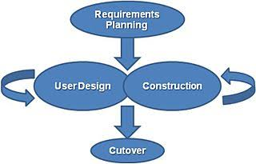

Figure 3.2 shows the different phases of the rapid application development methodology and the relationship of each stage to each other

**CHAPTER IV**

**Design and Methodology**

This chapter explains the process of the design and methodology sections for the development of the system Bulan Web-Based Incident, Activity Report and Monitoring Information System for Municipal Disaster Risk Reduction and Management Office (MDRRMO). It includes the concept, analysis and design, development model, development approach, software development tools, schedule and timeline, responsibilities, budget and cost management, verification and validation and testing. The developers uses Rapid Application Development (RAD) as its methodology to develop a software that requires minimum planning for rapid prototyping or the activity of making basic models or designs for a machine or other industrial product, thus, end users can produce better feedback when examining a live system, as opposed to working strictly with documentation.

This Memorandum Circular shall apply to all DSWD central and disaster risk reduction and management (DRRM) data and information. These reporting guidelines shall be observed by all agencies engaged in data generation, preparation, validation and dissemination from the national, regional, provincial, city/municipal levels and other stakeholders on the DSWD – DRRM data and information management.

A DROMIC report is prepared for every natural or human-induced disaster incident affecting at least thirty (30) families and/or causing damages to more than ten (10) houses. A report will also have to be submitted for incidents that required the Field Office to provide disaster relief assistance to affected families even if family beneficiaries are less than thirty (30).

**4.1 Requirements Planning**

At the first phase, gathering of data was conducted to evaluate the existing management system of the RD Office. This was significant to accurately distinguish the needs and to have a deeper insight about the office and its transactions. A “subjective” or “purposive sampling method” was employed in this study, this method is a non-probability sampling method that is selected based on the characteristics of a population and the objective of the study. The proponent believed that in order to obtain and to accurately distinguish the needed information, the researcher must carefully identify the type of respondents for the study. The Researchers believe that in order to obtain and to accurately distinguished the needed information, the researchers must utilize all the sample population.

Moreover, currently the Bulan Web-Based Incident, Activity Report and Monitoring Information System for Municipal Disaster Risk Reduction and Management Office (MDRRMO), used a descriptive survey research to review and the present status of the system for Municipality of Bulan page, thus a survey questionnaire that is aligned on the usual process in the information system was constructed to characterize them and give the weak spot of the existing system that has become the stronghold of the system development.

The survey questionnaire includes questions related to profile of the respondents: research proposal submission (these comprises of questions about the manner of submission) current system utilized (contains questions as regards to existing software developed, kind of repository being used and the efficiency and effectiveness of the existing system); utilizing, gathering and consolidating research data (which includes questions concerning the convenience of consolidation of data, period of time in consolidating) and; software solution development, to which the objective of these survey is to extract the needed information from the key informant in parallel to the objectives of the study and the foundation of the development of the system that will expedite the process of data management in the Office of the Municipality of Bulan page.

In addition, in order to formulate and to come up with the optimum solution suitable to the needs of the office, the proponent observed, analyzed and investigated the current flow of the Municipality of Bulan page, the data gathered during the investigation was organized and analyzed to come up with the best solution to address the challenges of the office.

After careful analysis and consideration of the data gathered during the need assessment survey and investigation, the proponent proposed the Bulan Web-Based Incident, Activity Report and Monitoring Information System for Municipal Disaster Risk Reduction and Management Office (MDRRMO), With the determination of delivering a suitable and dependable system not only for the respondents but to the researchers as well for they are also part as Beneficiaries.

**4.1.1 Architecture System Diagram**

**Pre - Flooding**

**During Flooding**

Flood Related

Variable

Situation

Assessment

observe

Email

flag

warming

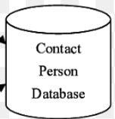

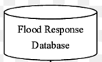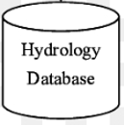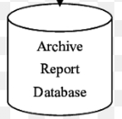

**Post - Flooding**

activate

Post - mortem

SMS

Archive Report

send

Get data

Report Generator Agent

Virtual Emergency Operation Centre

Notification

Agent

**Figure 4.1.1 Architecture System Diagram**

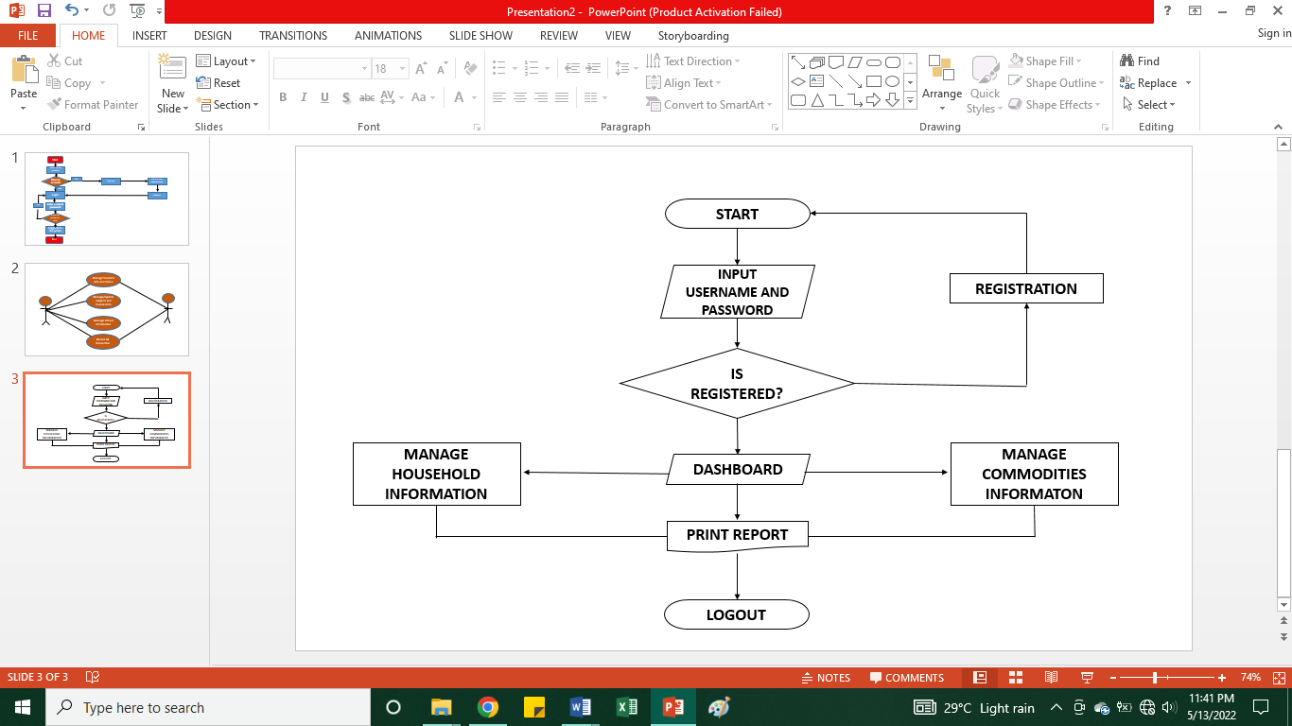**4.1.2 Flow Chart**

Flowchart Bulan Web-Based Incident, Activity Report and Monitoring Information System for Municipal Disaster Risk Reduction and Management Office (MDRRMO)

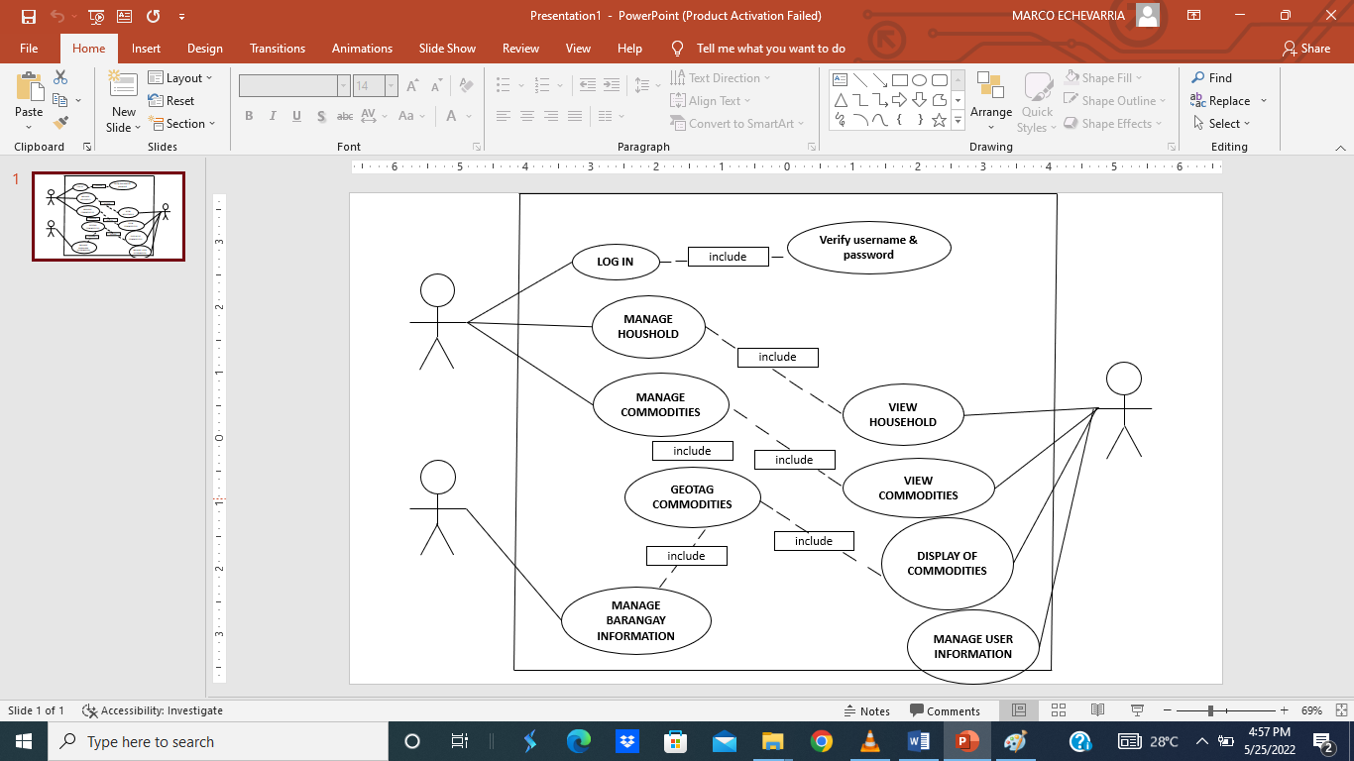**4.1.3 Use Case Diagram**

**Figure 4.1.3 Use Case Diagram of the system**

**4.1.4 Activity Diagram**

